ACCESSING PAYSTUBS IN THE EMPLOYEE PORTAL

Go to and Login:
1
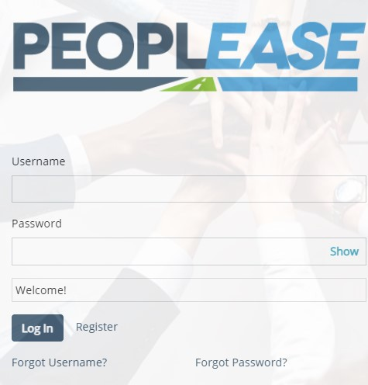
From the dashboard select the pay date, view more or pay history under the pay tab to access the pay detail.
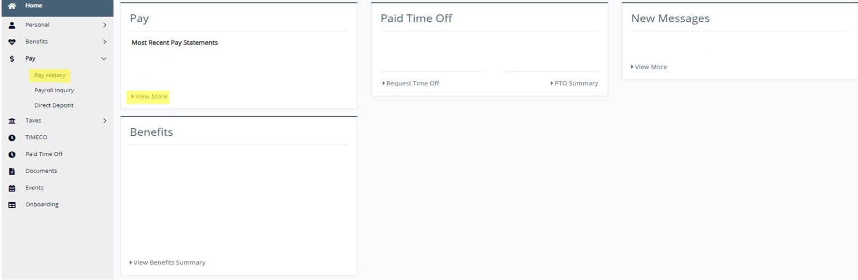
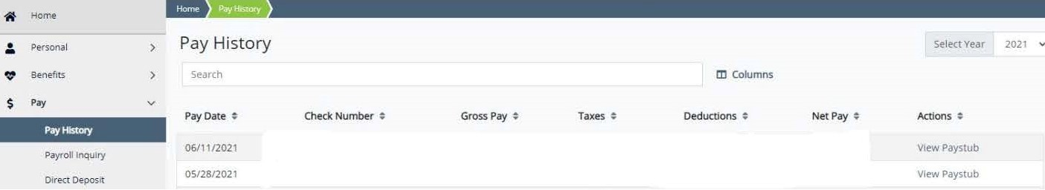
From Pay History and View More a list of statements will come up. Select View Paystub.
4
2
3

Pay Detail: In order to print complete paystub, select view check then a pdf document will come up at the bottom of the page.
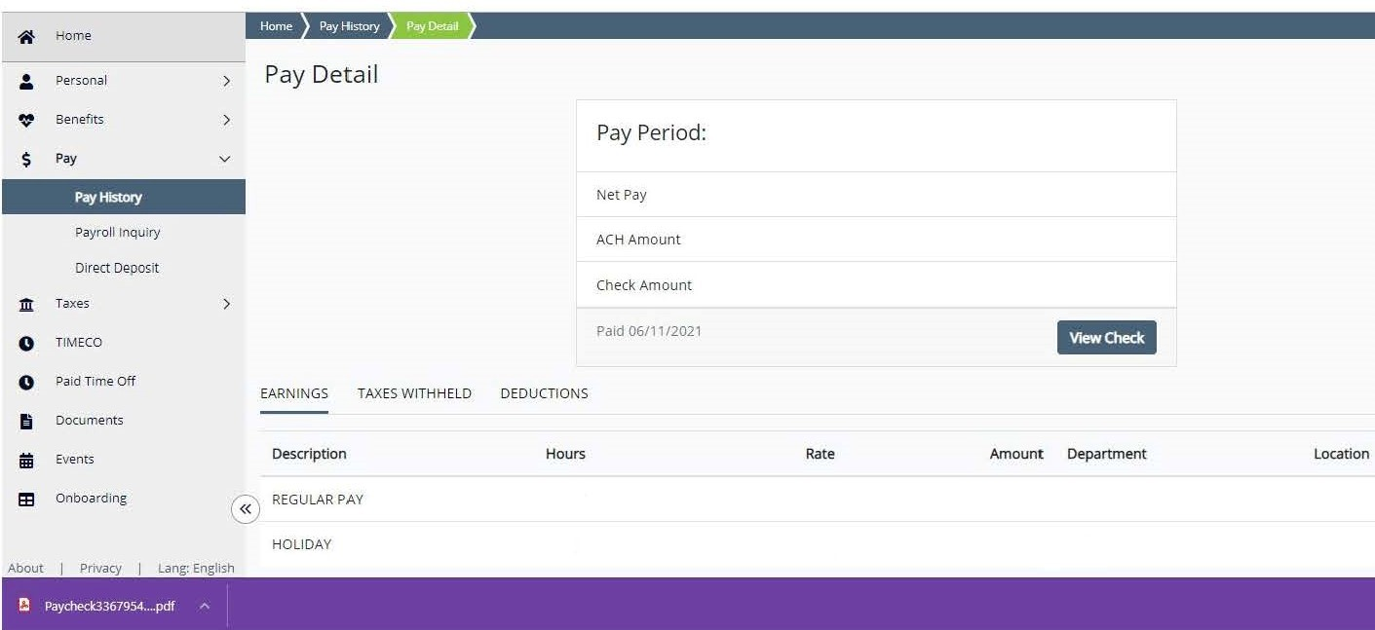
For questions regarding registration and log in access, please contact us at onboardingsupport@peoplease.com, or
1-833-879-9935. We are available Monday—Friday, 8am to 8pm EST.

